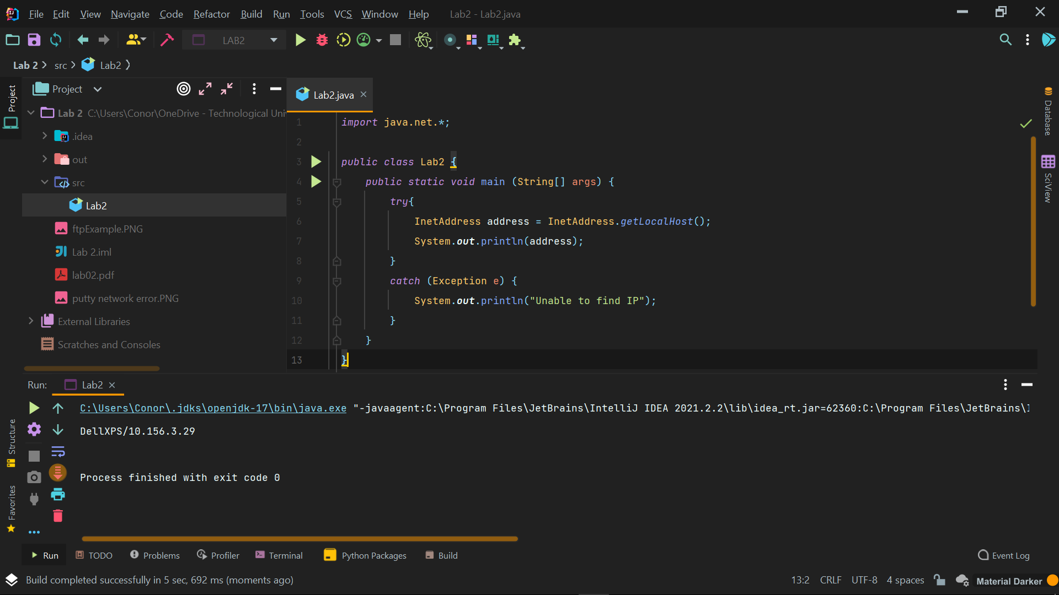

import java.net.\*;

public class getIP {

public static void main (String[] args) {

try{

InetAddress address = InetAddress.getLocalHost();

System.out.println(address);

}

catch (Exception e) {

System.out.println("Unable to find IP");

}

}

}

FTP Example

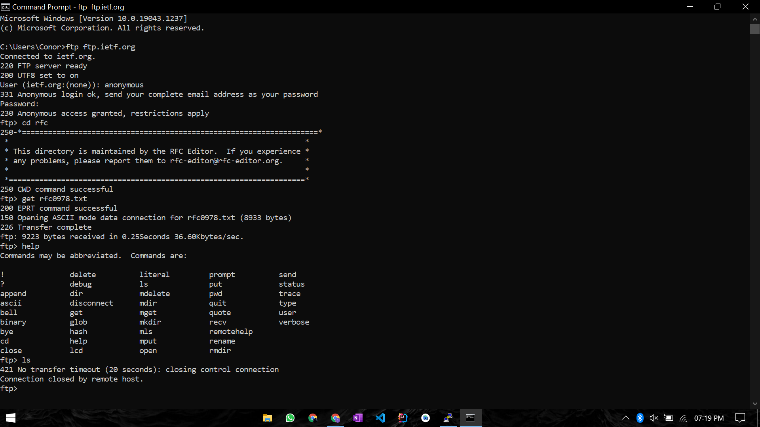

SSH Example

Unable to connect from home / find alternative linux server address. Also did not work from college lab machines

Testing Connections

import java.net.URL;

public class CheckConnections {

public static void main (String[] args) {

testProtocol("https://www.tudublin.ie/");

testProtocol("https://www.tudublin.ie/");

testProtocol("ftp://https://www.tudublin.ie/");

testProtocol("mailto:C19704439@mytudublin.ie");

}

public static void testProtocol(String url){

try {

URL u = new URL(url);

System.out.println(u.getProtocol() + " is supported");

}

catch (Exception ex) {

System.out.println(url + " is not supported");

}

}

}